Student’s name | …………………………………………………….…… | Grade | 6
Subject | Computer | Quiz No. | 1
Quiz No. ( 1 )

Question A: write the correct name of each part.

User | Man in the Middle | Web Applications
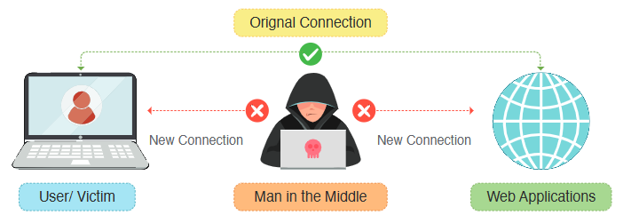
Good Luck
………………
………………
………………

